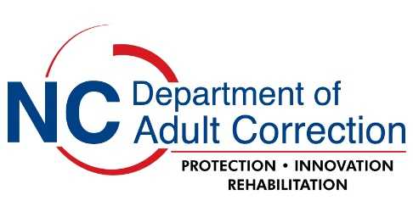
Project Closure

Project Title:

Principal Investigator:

NCDAC Project Number:

Research activities for this project are now complete. All data collection, use and/or analysis of data collected, or data provided by the Department of Adult Correction (DAC) as part of the research for this project has been concluded. I am requesting that the DAC research certification for this project be terminated.

In addition, I have read and understand the following.
- Closure of a study is considered a change in the activities of a research protocol and under federal regulations, must be reported to the IRB on record for this project.

- Copies of any publications (manuscripts or published documents) resulting from this research must be provided to the Research Authorization Panel chairperson (RAP) or DAC project sponsor.

- Disposal of all data collected or provided by DAC as part of this project will follow the process outlined in the most recently approved DAC Application for Research Approval on file.

- The sharing or use of data collected from DAC human subjects or DAC data obtained during this project is strictly prohibited.

- I may request that approval for a closed study be re-established if additional research activities are needed after closure. A new study may be required if significant time has passed since expiration, or if there are substantial changes to the study objectives or procedures.

___________________________________ Date: ___________________
Project Principal Investigator

