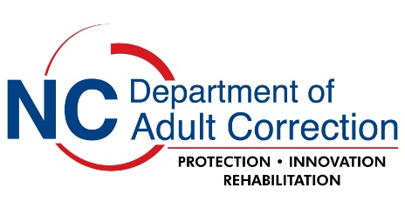
Renewal Request for Approval

Project Title:

Principal Investigator:

NCDAC Project Number: Dates of Prior Certification:

I am requesting the following action on the project referenced above.

This is the progress made to this point (include a brief paragraph that details what has been accomplished during the period):

Select one of the following options and provide the requested information:

For the next period of approval (a maximum of one year), I am requesting renewal of the project as most recently approved by the Department of Adult Correction (DAC). There are no changes to the project.

For the next period of approval (a maximum of one year), I am requesting renewal of the project with the following changes. NOTE: Any changes to a project require both IRB and DAC modification approval.

a change in the number of subjects required Please describe:

a change in the facility or facilities where the research is to be conducted
Please describe:

a change to the research design Please describe:

other changes or concerns
Please describe:

Are any of the modifications due to an unexpected or adverse event? Yes No
If yes, please explain:

Attach the following documents to an email and submit to administrative-analysis@dac.nc.gov.
- A completed copy of this renewal request form.

- A copy of your official approved IRB renewal letter from the IRB that granted original approval for the project.

If your renewal involves modifications to the project, you must also include the following.
  - A completed copy of the DAC modification request form.

  - A revised copy of your most recent DAC Application for Research Approval clearly indicating all modifications (e.g., Track changes or highlighting) you are requesting for this project.

  - A copy of your official approved IRB modification letter from the IRB that granted original approval for the project.

